|  |  |  |  |  |  |  |
| --- | --- | --- | --- | --- | --- | --- |
|  | |  | | Document No. | | Revision |
|  | |  | | 5 | | 1 |
|  | | | | | | |
| Document title | | **Master Document No. 5: Prototype research-based tool** | | | | |
|  | |  | | | | |
| Project | | Innovative Hybrid Energy System for Stable Power and Heat Supply in Offshore Oil & Gas Installation (HES-OFF) | | | | |
|  | |  | | | | |
| Work package | | H3: Design, testing and tuning | | | | |
|  | |  | | | | |
| Authors | | Roberto Agromayor, Marcin Pilarczyk, Erick Fernando Alves and Luca Riboldi | | | | |
|  | |  | | | | |
| Checked by | | Lars O. Nord and Elisabetta Tedeschi | | | | |
|  | |  | | | | |
|  | |  | | | | |
| Project partners | Znalezione obrazy dla zapytania ntnu | | Znalezione obrazy dla zapytania cmr prototech | | Znalezione obrazy dla zapytania lundin | | |

|  |  |
| --- | --- |
| Abstract | This document is the fifth document connected with the Master Document List (MDL) established for the HES-OFF project and is dedicated for the prototype research-based tool. The content of this document covers all points listed in the description included in the MDL. |

Contents

1 List of abbreviations: 3

1. Background 3

2. A prototype research-based tool general description 5

3. Integration of the models in one final model of the hybrid system 6

1.1 Long-term analysis 8

4. Definition of model inputs and outputs 11

4.1 Gas turbine – long-term analysis 11

4.2 Gas turbine – short-term analysis 11

4.3 Wind turbine – long-term analysis 12

4.4 Wind turbine – short-term analysis 12

4.5 Fuel cell – long-term analysis 13

4.6 Fuel cell – short-term analysis 13

4.7 Electrolyser – long-term analysis 14

4.8 Electrolyser – short-term analysis 14

5. Definition of needs of user interface 15

6. Programming / modeling language 15

9. Literature 15

# List of abbreviations:

RBT – research based tool

GT – gas turbine

FCS – fuel cell stack

ELY – electrolyzer

UI – user interface

# Background

The Hybrid Energy System for stable power and heat supply in OFFshore oil and gas installations (HES-OFF) concept combines a renewable energy source with an energy storage system (ESS) and conventional gas turbines (GTs). Fig. X depicts the HES-OFF concept.

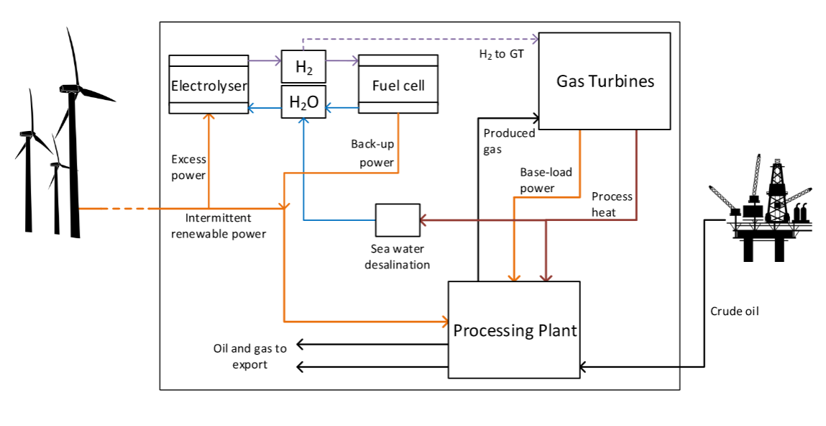Fig. X. The schematic of the HES-OFF concept.

The underlying idea is to exploit the full potential of the wind offshore resource and typical equipment of offshore installations by introducing an ESS consisting of stacks of proton exchange membrane (PEM) fuel cells (FCs) and electrolyzers (ELs) together with a subsea H2 storage system. The PEM technology was chosen as the most appropriate for this concept due to its fast-dynamic response, good efficiency and relative maturity. This HES-OFF is expected to offer significant advantages:

* Full exploitation of renewable energy sources: the ESS allows the storage of excessive wind energy that otherwise would have been immediately converted into heat to avoid grid overloading.
* Removal of redundant GTs: back-up power is guaranteed by the FC stack thus it might be possible to remove redundant GTs.
* Full exploitation of renewable energy sources: the ESS allows the storage of excessive wind energy that otherwise would have been immediately converted into heat to avoid grid overloading.
* Removal of redundant GTs: back-up power is guaranteed by the FC stack thus it might be possible to remove redundant GTs.
* Increased security of power supply: a properly designed ESS helps to cope with unforeseen variations of wind power and demand allowing a more flexible operation of the plant.
* Improved operation of the GT: use of a cleaner fuel (H2) and a more efficient operational strategy that do not directly respond to wind fluctuations.
* Additional electric grid stability: the ESS acts as a buffer smoothing out the fluctuations of the wind power system

More details about HES-OFF concept and its components are available in the other Master Documents i.e. Case study info [1] and Process modeling [2]. The first document contains literature surveys on selected topics such as offshore energy supply, hybrid systems, offshore grids and a description on the case study i.e. Edvard Grieg field. The second document presents the integrated model developed to simulate the process and grid performances of the HES-OFF concept and the main features of the sub-models and their interactions. In addition to that, further information about the case study and a wind farm integration into offshore power plant is discussed in [3].

# A prototype research-based tool general description

One objective of the research activities within the HES-OFF project is to develop a prototype research-based computer tool for the design and evaluation of hybrid based concepts to be used by industry in the definition of the most effective design for a specific oil project. Provided with the necessary input information (e.g. energy requirements, system constraints, economic parameters), the tool will return the optimum design of a hybrid energy system, including the installed capacities and the level of integration. The tool will also allow for a comprehensive evaluation of the system’s performance, throughout the expected lifetime of the installation. The tool will benefit from the testing campaign in a hardware-in-the-loop simulation consisting of fuel cell, electrolyser, hydrogen storage, converters, and power generators and loads which simulates the primary power producers (i.e. wind turbines) and the main load (the offshore platform). The results from the testing will be used to validate the results from the simulation of specific components of the hybrid system.

The research-based tool developed in the project might be used as a decision-making tool for the definition of the more effective concept to develop new projects. The availability for industry of such a comprehensive tool in an early-stage of development of an oil project could result in substantial future savings. ~~There are today no such tools that are developed for offshore applications where especially the high cost of power failure plays a crucial role.~~

The tool is to be realized for industrial users, thus with a limited computational effort required and calculation times in the order of hours. Moreover, the tool is to be based on open source software in order to maximize its accessibility for industry.

The research-based tool will rely on an integrated model of hybrid systems for the supply of energy offshore. The development of the integrated model for the HES-OFF concept is described in the deliverable *Document No. 4: Process modeling*. The same model is to be used in the research-based tool, to which proper modifications will be implemented in order to make it suitable for a larger range of possible hybrid systems. The process of development of the integrated model is described by the following steps:

* Development of a computer model representing the power generation system: the validation (errors within few percentage points) against industrial or literature data will confirm the reliability of the model.
* Development of a computer model representing the offshore grid: the validation (errors within few percentage points) against experimental or literature data will confirm the reliability of the model.
* Development of a computer model representing the fuel cell and electrolyser stacks, ~~including water and thermal management~~: the validation (errors within few percentage points) against experimental or literature data will confirm the reliability of the model.
* Development of an integrated model: the integrated model will need to be able to process inputs from the models and return correct outputs, with reasonable calculation times (in the order of seconds) so to allow its utilization in optimization procedures.
* Development of an optimization procedure to be applied on the integrated model: the optimization procedure will be tested to evaluate its capability to return global minima within reasonable calculation times. ~~The uncertainty involved in the optimization procedure will be evaluated.~~
* ~~Evaluation of case studies utilising the integrated model: testing activities will be carried out to identify failure risks, overall reliability and maintenance strategy.~~
* Testing of the submodels with real hardware at NTNU’s and Prototech’s laboratories: the stability of the micro-grid will be assessed by ensuring the compliance of the main grid quantities with corresponding limits set in relevant standards (e.g. voltage variations within +/-10% in steady state conditions and +/-20% in transient conditions, and frequency variations within +/- 5% in steady state conditions and +/-10% in transient conditions)

# Integration of the models in one final model of the hybrid system

An integrated model has been developed to assess the HES-OFF performance for given case-study i.e. offshore installation in the North Sea (Edvard Grieg). Integrated model compromises *Process models* and *Grid model* (see Fig. X).

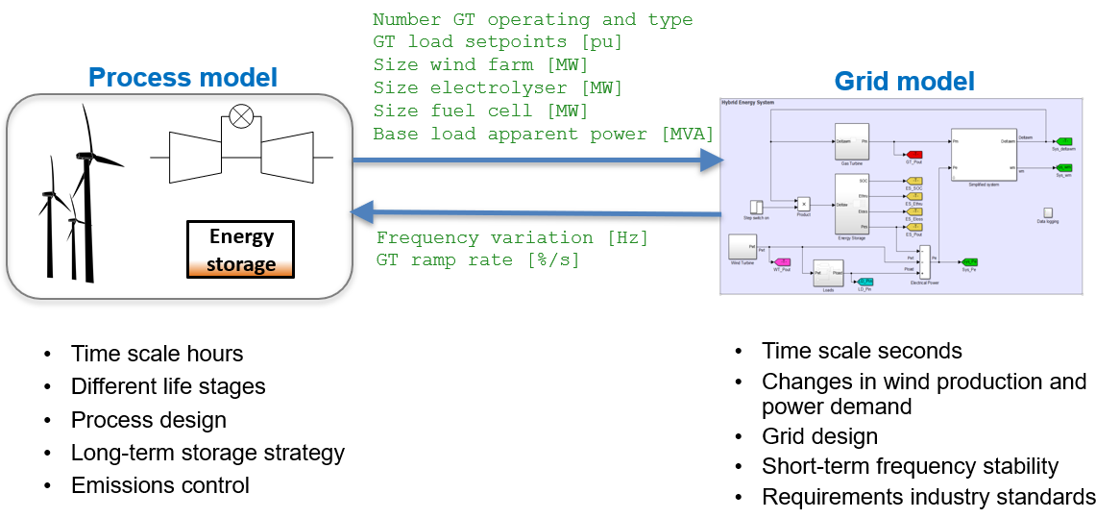

Fig. X. Schematic of the Integrated model and interactions between its submodels.

RBT allows performing two types of simulations i.e. long-term and short-term analysis. The long-term approach define a design and assess its performance over the lifetime of the plant while short-term approach check if a given design complies to requirements in industry standards in terms of grid stability. In addition to that the distinction between long-term and short-term analysis yields different models and inputs to be incorporated. The work [4] provides more details about applied methodology. The main differences between long-term and short-term analysis are listed in table Y.

Table Y. Main differences between long-term and short-term analysis.

|  |  |  |
| --- | --- | --- |
|  | **Long-term analysis** | **Short-term analysis** |
| **Fundamental requirement** | * Ensure that power demand is met at any time | * Frequency stability during changes in wind production and power demand |
| **Design objectives** | * Minimize the CO2 emissions * Utilize a single GT (when possible) * Maximize exploitation offshore wind | * fmin < limit: increase fuel cell size * fmax > limit: increase electrolyser size |
| **Constraints** | * Close the H2 balance | * Keep GTs ramp rate below rated value |
| **Inputs to the design** | * Type of GT (LM2500 vs LM6000) * GT operation (max/min load) * Max. fraction of H2 in GT * Size wind farm (12, 18 and 24 MW) * Wind turbine * Size fuel cell and electrolyser stacks * H2 storage method | * Type of GT (LM2500 vs LM6000) * GT operation (max/min load) * Size wind farm (12, 18 and 24 MW) * Wind turbine type * Size fuel cell and electrolyser stacks * Power demand profile * Wind speed profile |
| **Outputs** | * Size H2 storage * Cumulative CO2 emissions * Size fuel cell and electrolyser stacks | * Max/min frequency deviation [Hz] * Max GT ramp rate [%/s] |

An integrated model of the proposed system was developed combining sub-models of the process and the electric grid components. This integrated model allows designing the hybrid energy system for maximum process performance, while simultaneously verifying the stable operation of the offshore grid. This approach not only helps avoiding designs that would prove operationally unfeasible, but actively directs the design process towards optimal solutions by considering the mutual influence of the process and the electric domains. Figure W gives an overview of the design approach based on the integrated model. More details are presented in the following sections.

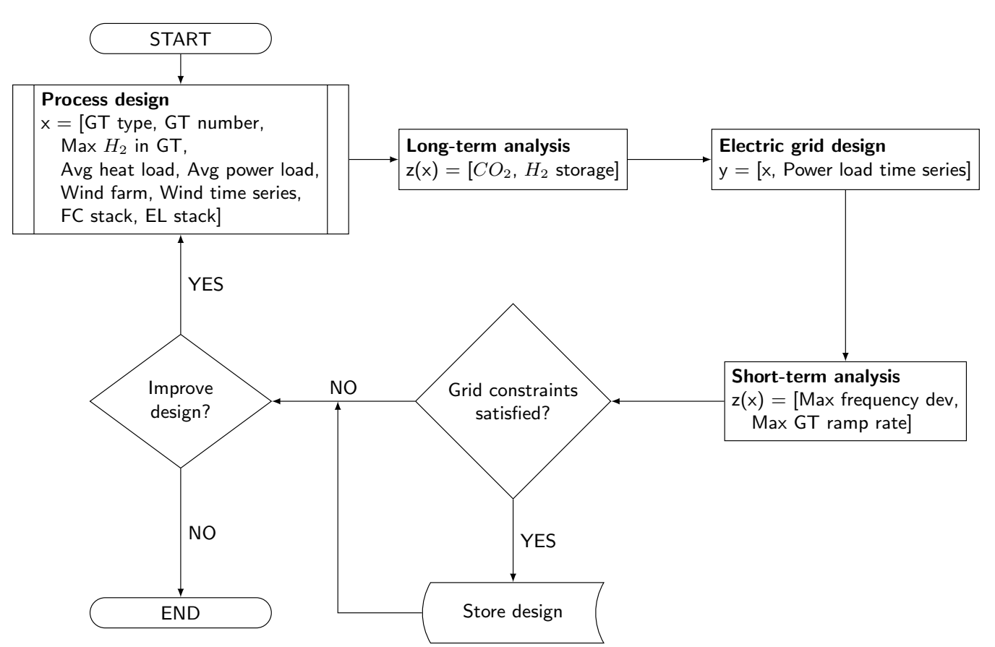

Fig. W. Flowchart of the proposed design methodology combining models of the process and electric domains.

## Long-term analysis

The overall structure of RBT along with options changeable by the user is depicted in fig. X.

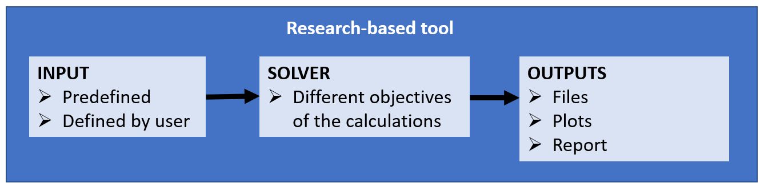

Fig. X. Options changeable by the user in RBT.

To create a universal tool it is envisioned that user can select the following options and inputs in RBT. Such approach allows to provide a wide scope of application of the tool and tailor the calculation outputs to user's needs. The following table Y specifies the details of the changeable options in inputs to RBT according to Fig. X.

Table Y. Inputs specification to integrated model in User Interface. *Legend: Predefined model; Model defined by user; Predefined and changeable value.*

|  |  |  |  |  |  |  |
| --- | --- | --- | --- | --- | --- | --- |
|  | **1st Level Option [Yes/No]** | **2nd Level Option Options** | | **3rd Level Option Options** | **4th Level Option** | **Comment** |
| HES-OFF component models | Gas turbine [Yes;  Yes – estimate the number  model of GTs] | Quantity [1,2] | | LM2500+G4 [No, 0; Yes, 1; Yes, 2] | Max. vol% content of H2 in fuel [% value; default 20 vol.% ] | GT is a obligatory component. User can specify number and model of GT. GT max. ramp rate and volumetric content of H2 co-fed to GT is predefined but user has freedom to introduce own values. |
| Max. GT load [% value; default 90%] |
| Min. GT load [% value; default 40%] |
| Max. GT ramp rate [value in %/s; default 14.7%/s] |
| LM6000 [No, 0; Yes, 1; Yes, 2] | Max. vol% content of H2 in fuel [% value; default 20 vol.% ] |
| Max. GT load [% value; default 90%] |
| Min. GT load [% value; default 40%] |
| Max. GT ramp rate [value in %/s; default 14.7%/s] |
|
| Wind Turbine [Yes/No] | Model 1 (3 MW) | | Quantity [0, 1, 2, 3, ...] | n/a but potentially each WT can be tied to different time series (?) | WT model will use wind time serie to generate input power to HES-OFF system. |
| Model 2 (6 MW - Siemens Gamesa SWT 6.0-154) | | Quantity [0, 1, 2, 3, ...] |
| Model 3 (12 MW) | | Quantity [0, 1, 2, 3, ...] |
| Model 4 - defined by user | | Quantity [0, 1, 2, 3, ...] |
| Fuel cell stack [Yes - constant performance; Yes - variable performance; No] | 2nd and higher levels are available only if variable performance is selected | Model 1 - predefined PowerCell | Max. Capacity [value in MW] | Degradation [Yes/No] | Model 1 incorporates simple polynomials. Model 2 calculates by seperate scripts polynomial for given inputs. |
| Model 2 - inputs from user | Max. Capacity [value in MW] | Degradation [Yes/No] |
| Electrolyser stack [Yes - constant performance; Yes - variable performance; No] | Model 1 - predefined NEL Hydrogen | Max. Capacity [value in MW] | Degradation [Yes/No] | Model 1 incorporates simple polynomials. Model 2 calculates by seperate scripts polynomial for given inputs. |
| Model 2 - inputs from user | Max. Capacity [value in MW] | Degradation [Yes/No] |
| Hydrogen storage [Yes/No] | Max. Capacity [value in kgH2 ; default 50 000 kgH2] | | n/a | n/a | It is assumed that the Hydrogen is stored in gaseous form under pressure of 30 bar (pressure of ELY) |
| Hybrid energy storage [Yes/No] |  |  |  |  | Erick feel free to provide inputs |
| Extra inputs | Wind data series [Obligatory if WT is selected] | Wind data series No. 1 | | n/a | n/a | Wind correction factor hhub is predifined in WT models. But for WT model 4 user must provide hhub value. Wind data series should be obtained from specific location of the WT. |
| Wind data series No. 2 | | n/a | n/a |
| Wind data series No. 3 | | hhub [value in m] | n/a |
| Heat demand of offshore platform [Obligatory] | Peak demand [value in MW; default 14.0 MW] | | Period [years; default 2 yrs] | n/a |  |
| Mid-life demand [value in MW; default 11.0 MW] | | Period [years; default 4 yrs] | n/a |  |
| Tail demand [value in MW; default 32.9 MW] | | Period [years; default 12 yrs] | n/a |  |
| Power demand of offshore platform [Obligatory] | Peak demand [value in MW; default 8.0 MW] | | Period [years; default 2 yrs] | n/a |  |
| Mid-life demand [value in MW; default 35.2 MW] | | Period [years; default 4 yrs] | n/a |  |
| Tail demand [value in MW; default 32.9 MW] | | Period [years; default 12 yrs] | n/a |  |

I am not sure if parameters for optimization should be included in this table as parameters which user can change (population size, max. number of generations, etc.)

The outputs of the research tool should be well-thought as well (plots, tables, files (?).

The inputs and parameters specified in Table Y should be introduced by user from the User Interface.

# Definition of model inputs and outputs

This point discusses the interaction between components models occur directly in Solver behind the UI mask. User has no influence on the interactions specified in the following tables. Some of inputs specified via User Interface are taken into account (table Y).

## Gas turbine – long-term analysis

|  |  |  |  |
| --- | --- | --- | --- |
| **Inputs** | | | |
| **Parameter** | **Unit** | **Source** | **Comment** |
| Power – Pt | kW | Power demand |  |
| Heat – Qt | kW | Heat demand |  |
|  |  |  |  |

|  |  |  |  |
| --- | --- | --- | --- |
| **Outputs** | | | |
| **Parameter** | **Unit** | **Recipient** | **Comment** |
|  |  |  |  |
|  |  |  |  |
|  |  |  |  |

## Gas turbine – short-term analysis

|  |  |  |  |
| --- | --- | --- | --- |
| **Inputs** | | | |
| **Parameter** | **Unit** | **Source** | **Comment** |
|  |  |  |  |
|  |  |  |  |
|  |  |  |  |

|  |  |  |  |
| --- | --- | --- | --- |
| **Outputs** | | | |
| **Parameter** | **Unit** | **Recipient** | **Comment** |
|  |  |  |  |
|  |  |  |  |
|  |  |  |  |

## Wind turbine – long-term analysis

|  |  |  |  |
| --- | --- | --- | --- |
| **Inputs** | | | |
| **Parameter** | **Unit** | **Source** | **Comment** |
| Power – Pt | kW | Power demand |  |
| Heat – Qt | kW | Heat demand |  |
|  |  |  |  |

|  |  |  |  |
| --- | --- | --- | --- |
| **Outputs** | | | |
| **Parameter** | **Unit** | **Recipient** | **Comment** |
|  |  |  |  |
|  |  |  |  |
|  |  |  |  |

## Wind turbine – short-term analysis

|  |  |  |  |
| --- | --- | --- | --- |
| **Inputs** | | | |
| **Parameter** | **Unit** | **Source** | **Comment** |
|  |  |  |  |
|  |  |  |  |
|  |  |  |  |

|  |  |  |  |
| --- | --- | --- | --- |
| **Outputs** | | | |
| **Parameter** | **Unit** | **Recipient** | **Comment** |
|  |  |  |  |
|  |  |  |  |
|  |  |  |  |

## Fuel cell – long-term analysis

|  |  |  |  |
| --- | --- | --- | --- |
| **Inputs** | | | |
| **Parameter** | **Unit** | **Source** | **Comment** |
| Power – Pt | kW | Power demand |  |
| Heat – Qt | kW | Heat demand |  |
|  |  |  |  |

|  |  |  |  |
| --- | --- | --- | --- |
| **Outputs** | | | |
| **Parameter** | **Unit** | **Recipient** | **Comment** |
|  |  |  |  |
|  |  |  |  |
|  |  |  |  |

## Fuel cell – short-term analysis

|  |  |  |  |
| --- | --- | --- | --- |
| **Inputs** | | | |
| **Parameter** | **Unit** | **Source** | **Comment** |
|  |  |  |  |
|  |  |  |  |
|  |  |  |  |

|  |  |  |  |
| --- | --- | --- | --- |
| **Outputs** | | | |
| **Parameter** | **Unit** | **Recipient** | **Comment** |
|  |  |  |  |
|  |  |  |  |
|  |  |  |  |

## Electrolyser – long-term analysis

|  |  |  |  |
| --- | --- | --- | --- |
| **Inputs** | | | |
| **Parameter** | **Unit** | **Source** | **Comment** |
| Power – Pt | kW | Power demand |  |
| Heat – Qt | kW | Heat demand |  |
|  |  |  |  |

|  |  |  |  |
| --- | --- | --- | --- |
| **Outputs** | | | |
| **Parameter** | **Unit** | **Recipient** | **Comment** |
|  |  |  |  |
|  |  |  |  |
|  |  |  |  |

## Electrolyser – short-term analysis

|  |  |  |  |
| --- | --- | --- | --- |
| **Inputs** | | | |
| **Parameter** | **Unit** | **Source** | **Comment** |
|  |  |  |  |
|  |  |  |  |
|  |  |  |  |

|  |  |  |  |
| --- | --- | --- | --- |
| **Outputs** | | | |
| **Parameter** | **Unit** | **Recipient** | **Comment** |
|  |  |  |  |
|  |  |  |  |
|  |  |  |  |

# Definition of needs of user interface

User interface should be straightforward for external users who were not involved in HES-OFF project. The windows should define clearly what is needed from user and what mode of calculation (objectives) is needed. The results obtained by the tool should be presented in tabular form and optionally on plots. The future users of the tool are supposed to know the general purpose of the tool and understand the required input to the program as well as should know the general idea of the HES-OFF project.

The research based tool is expected as .exe file which can be installed on Window computers. The tool should use the computational resources of the computer (i.e. all physical cores) to provide quick and efficient calculations.

# Programming / modeling language

Python.

1. Optimization procedure enabling fast calculation

An optimization framework was developed to identify the optimal designs for the HES-OFF. The input parameters for the optimization problem (i.e., the decision variables) are those deemed having the largest impact on the performances. They are illustrated in table 1 with their selected lower and upper bounds. The values presented in Table 1 are obtained in work [4], however the user has freedom to specify own values.

Table 1. Input parameters for the optimization problem

|  |  |  |  |
| --- | --- | --- | --- |
| **Decision variables** | **Unit** | **Lower bound** | **Upper bound** |
| **GT type** | - | LM2500 | LM6000 |
| **GT number** | - | 1 | 2 |
| **Max. H2 in GT** | Vol% | 0 | 20 |
| **Wind farm size** | MW | 12 | 24 |
| **FC stack size** | MW | 1 | 5 |
| **EL stack size** | MW | 2 | 8 |

The metrics selected to analyze the performance of a design (i.e., the objective functions) are the cumulative CO2 emissions and the H2 storage size. Both objectives are to be minimized by the optimizer. ~~To explore only the space considered of interest, an additional constraint was established, that is to discard designs leading to an H2 storage size larger than 50,000 kg.~~ A multi-objective constrained optimization problem is so defined. A meta-heuristic approach was selected to solve the optimization problem. The genetic algorithm using the MATLAB Global Optimisation Toolbox was implemented, with the following characteristics:

* Population size: 500
* Maximum number of generations = 10
* Function tolerance = 10−3
* Number of stall generations: 5

1. Testing and validation of research-based tool

# Literature

|  |  |
| --- | --- |
| [1] | Master Document No. 1: Case study info. Available online: [https://spfarm.ntnu.no/sites/project/323/_layouts/15/WopiFrame.aspx?sourcedoc={04D6CDE4-5B3D-48F9-A5C3-174553568B1A}&file=Document%201%20-%20Case%20Study%20Info%20v5.pdf&action=default](https://spfarm.ntnu.no/sites/project/323/_layouts/15/WopiFrame.aspx?sourcedoc=%7b04D6CDE4-5B3D-48F9-A5C3-174553568B1A%7d&file=Document%201%20-%20Case%20Study%20Info%20v5.pdf&action=default) |
| [2] | Master Document No. 4: Process modeling. Available online:  [https://spfarm.ntnu.no/sites/project/323/_layouts/15/WopiFrame.aspx?sourcedoc={7A8F6EBC-134F-45AB-8CD0-8C3354F2D538}&file=Deliverable%20activity%20H2%20-%20Integrated.pdf&action=default](https://spfarm.ntnu.no/sites/project/323/_layouts/15/WopiFrame.aspx?sourcedoc=%7b7A8F6EBC-134F-45AB-8CD0-8C3354F2D538%7d&file=Deliverable%20activity%20H2%20-%20Integrated.pdf&action=default) |
| [3] | Riboldi, L.; Nord, L.O. Offshore Power Plants Integrating a Wind Farm: Design Optimisation and Techno-Economic Assessment Based on Surrogate Modelling. Processes **2018**, 6, 249. |
| [4] | Riboldi, L; Erick, F.A.; Pilarczyk, M.; Tedeschi, E.; Nord, L.O. Optimal design of a hybrid energy system for the supply of clean and stable energy to offshore installations. Frontiers. Under review. |
| 5 |  |
| 6 |  |
| 7 |  |
| 8 |  |
| 9 |  |
| 10 |  |